**CREATING A CLASSIC LOAD BALANCER WITH A WINDOWS INSTANCE**

Create a Windows Instance with a Security Group having inbound rules as “HTTP” and “RDP”. Activate a webserver **IIS (Internet Information Services)** in the instance.

Once opened the Windows instance server, search for **“Server Manager”**and open it.

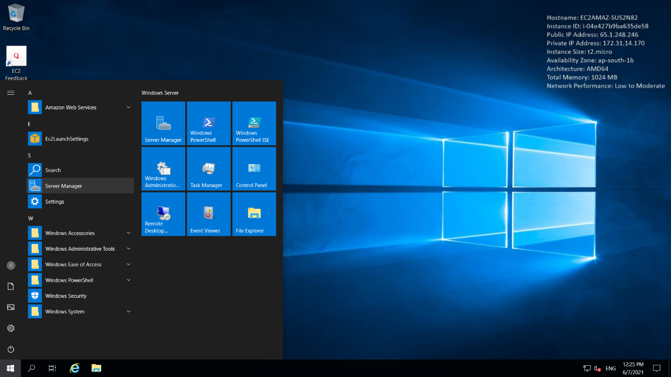

Then click on “Add Roles and Features” and then check the box “Windows IIS” in the Roles section which makes install IIS features in the instance.

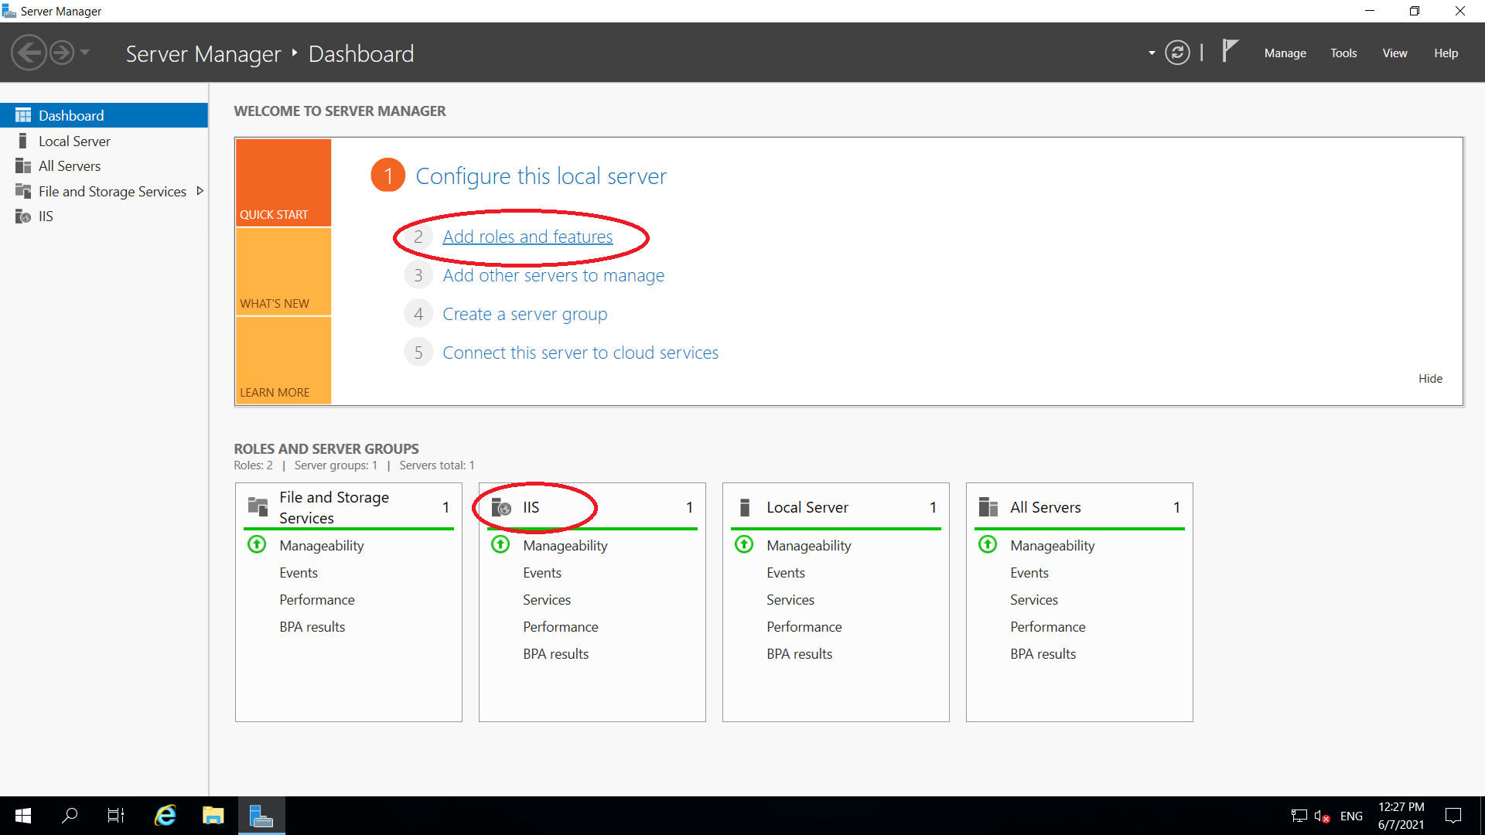

Once activate IIS feature in the instance, go to the path C:/inetpub/wwwroot. Place your index html file in that folder.

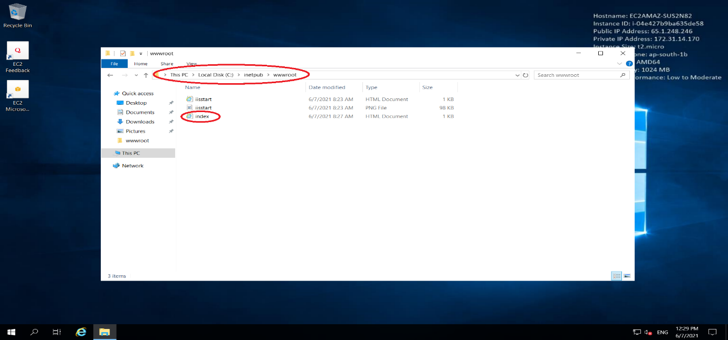

Now, your windows instance is ready. To check, copy the public IPv4 address of the instance and paste it on web browser. It will show the contents in the html file.

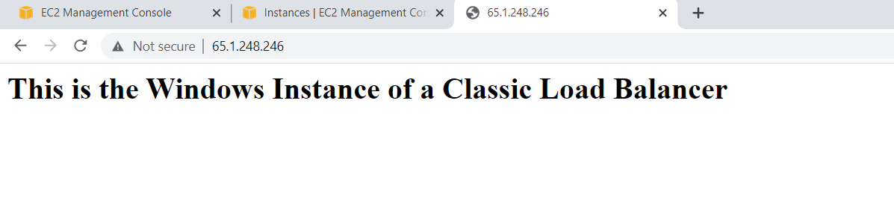

Now create a Classic Load Balancer with a Security Group having only “HTTP” as Inbound rules. Then attach the Windows instance to this Classic Load Balancer. Once the instance status will be coming to “InService”, copy the DNS name of the load balancer.

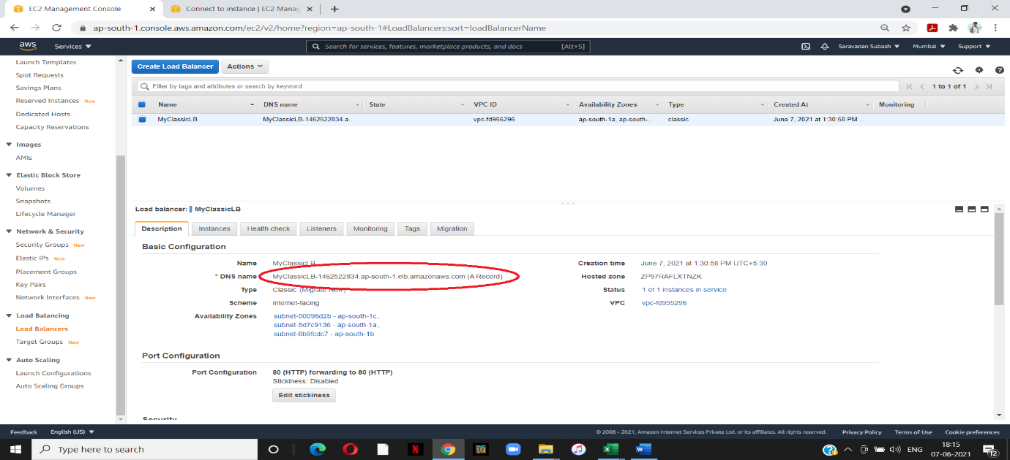

Then paste that DNS name in the web browser and enter. It will result the same html file saw with the instance public IPv4 address.

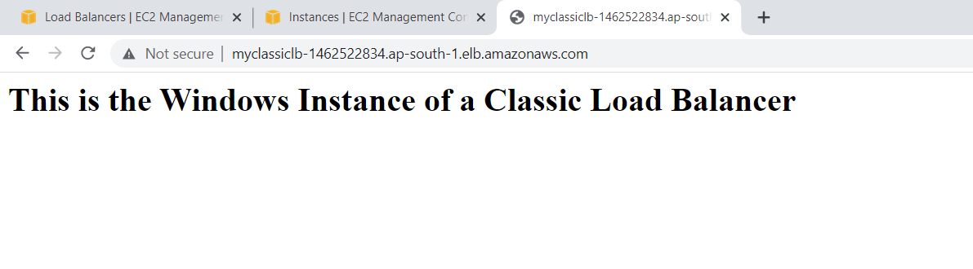

We can restrict the access of HTML file through IPv4 address and access only through Classic Load Balancer. For that, we need to change the security group of the Windows instance. Update the source of the security group to the Classic Load Balancer’s Security Group.

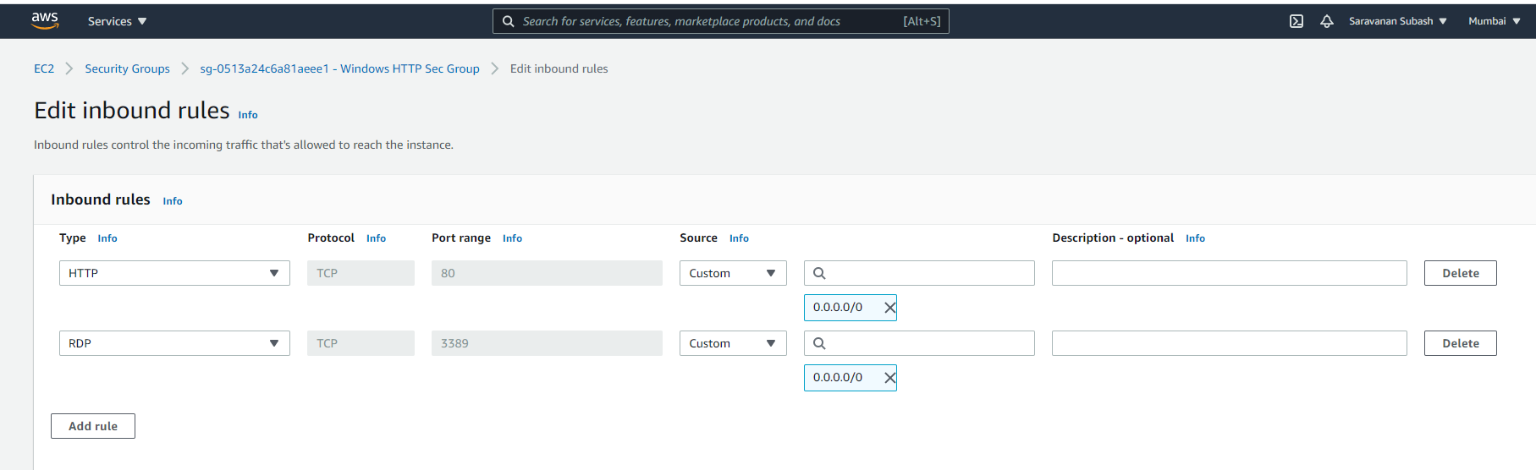

Select the security group of the Load Balancer as a source for the Windows instance security group so that HTML file will be accessed only through DNS and not by public IPv4 address.

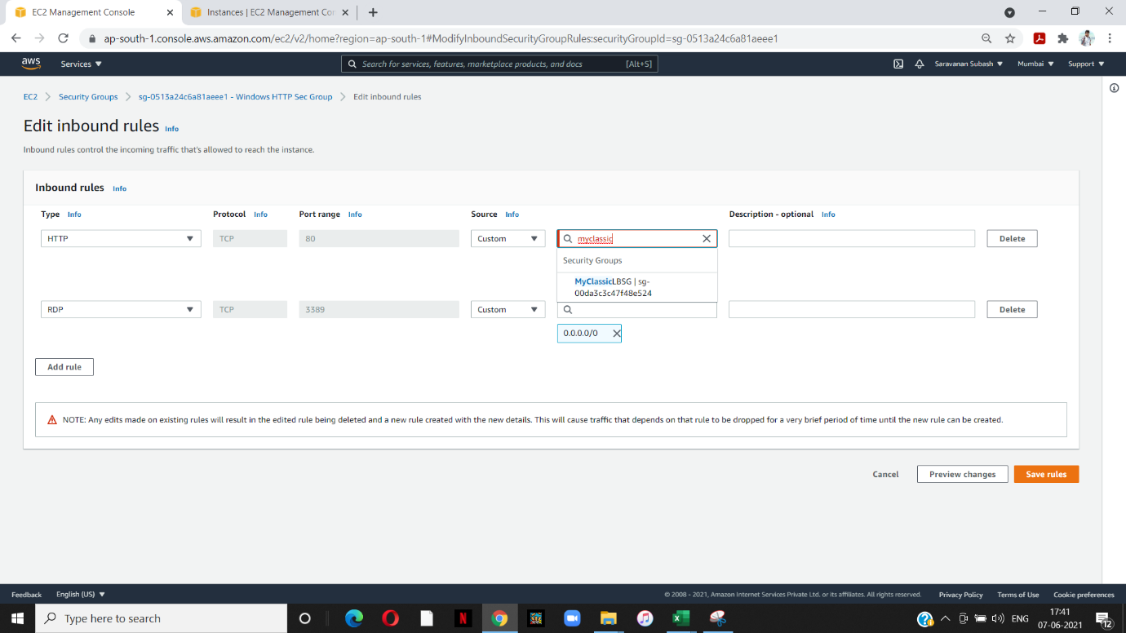

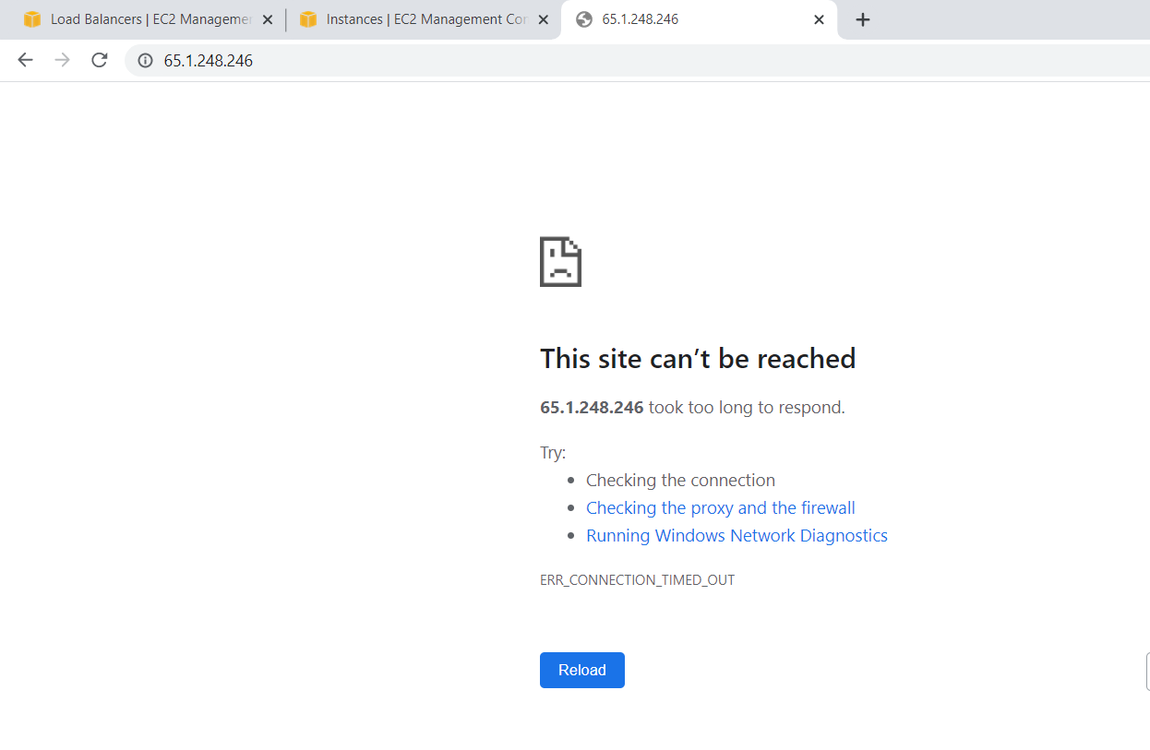

Thus, we can restrict the public access of the instance and route through load balancer.

